Experiment – 17
Implement Mobile Price Prediction using appropriate machine learning algorithm

Aim
To predict the price of a mobile phone based on its specifications using the Linear Regression algorithm.

Algorithm
- Import the required libraries and LinearRegression model.
- Create the five given mobile datasets.
- Separate the input features X and target price y.
- Create a Linear Regression model.
- Train the model using model.fit(X, y).
- Provide the new mobile specifications as input.
- Predict the mobile price using model.predict().
- Display the predicted price for each dataset.

Program:
import numpy as np
import pandas as pd
from sklearn.linear_model import LinearRegression
def predict_price(dataset_name, X, y, new_sample):
print("\n" + "=" * 65)
print(dataset_name)
print("=" * 65
model = LinearRegression()
model.fit(X, y)
prediction = model.predict(new_sample)
print("Predicted Mobile Price: ₹", round(prediction[0], 2))
print("\nModel Coefficients:")
print(model.coef_)

print("Intercept:", round(model.intercept_, 2))
return prediction[0]
# RAM (GB), Storage (GB), Camera (MP)
X1 = np.array([
[4, 64, 12],
[4, 128, 16],
[6, 128, 48],
[6, 256, 50],
[8, 128, 64],
[8, 256, 64],
[12, 256, 108],
[12, 512, 108],
[16, 512, 200],
[16, 1024, 200]
])
y1 = np.array([
12000,
15000,
18000,
22000,
25000,
30000,
38000,
45000,
60000,
75000
])
new1 = np.array([[8, 256, 108]])
price1 = predict_price(
"DATASET 1: MOBILE SPECIFICATIONS VS PRICE",
X1, y1, new1
)
X2 = np.array([
[1.8, 4, 4000],
[2.0, 4, 4500],
[2.2, 6, 5000],
[2.4, 6, 5000],
[2.6, 8, 5500],
[2.8, 8, 6000],
[3.0, 12, 6000],
[3.2, 12, 6500],
[3.4, 16, 7000],
[3.6, 16, 7000]
])
y2 = np.array([
10000,
12000,
17000,
21000,
26000,
32000,
40000,
50000,
62000,
76000
])
new2 = np.array([[2.9, 8, 6000]])
price2 = predict_price(
"DATASET 2: PROCESSOR PERFORMANCE VS MOBILE PRICE",
X2, y2, new2
)
X3 = np.array([
[6.1, 60, 4000],
[6.2, 90, 4500],
[6.4, 90, 5000],
[6.5, 120, 5000],
[6.6, 120, 5500],
[6.7, 120, 6000],
[6.8, 144, 6000],
[6.9, 144, 6500],
[7.0, 165, 7000],
[7.1, 165, 7000]
])
y3 = np.array([
12000,
15000,
18000,
23000,
28000,
34000,
42000,
52000,
65000,
78000
])
new3 = np.array([[6.7, 144, 6000]])
price3 = predict_price(
"DATASET 3: DISPLAY FEATURES VS MOBILE PRICE",
X3, y3, new3
)
X4 = np.array([
[4, 6, 64],
[6, 8, 128],
[8, 8, 128],
[8, 8, 256],
[12, 8, 256],
[12, 8, 512],
[16, 8, 512],
[16, 8, 1024],
[18, 8, 1024],
[24, 8, 1024]
])

y4 = np.array([
14000,
19000,
26000,
32000,
42000,
52000,
65000,
82000,
95000,
120000
])
new4 = np.array([[12, 8, 512]])
price4 = predict_price(
"DATASET 4: PREMIUM SMARTPHONE DATASET",
X4, y4, new4
)
X5 = np.array([
[250000, 4000, 48],
[320000, 4500, 50],
[420000, 5000, 64],
[520000, 5000, 64],
[620000, 5500, 108],
[720000, 6000, 108],
[820000, 6000, 200],
[920000, 6500, 200],
[1020000, 7000, 200],
[1120000, 7000, 200]
])

y5 = np.array([
15000,
18000,
24000,
30000,
38000,
46000,
58000,
70000,
85000,
100000
])
new5 = np.array([[750000, 6000, 108]])
price5 = predict_price(
"DATASET 5: OVERALL MOBILE PERFORMANCE DATASET",
X5, y5, new5
)
results = pd.DataFrame({
"Dataset": [
"Mobile Specifications",
"Processor Performance",
"Display Features",
"Premium Smartphone",
"Overall Performance"
],
"Predicted Price (₹)": [
price1,
price2,
price3,
price4,
price5
]
})
print("\n\n")
print("=" * 65)
print("FINAL MOBILE PRICE PREDICTION RESULTS")
print("=" * 65)
results["Predicted Price (₹)"] = results["Predicted Price (₹)"].round(2)
print(results.to_string(index=False))
Output:
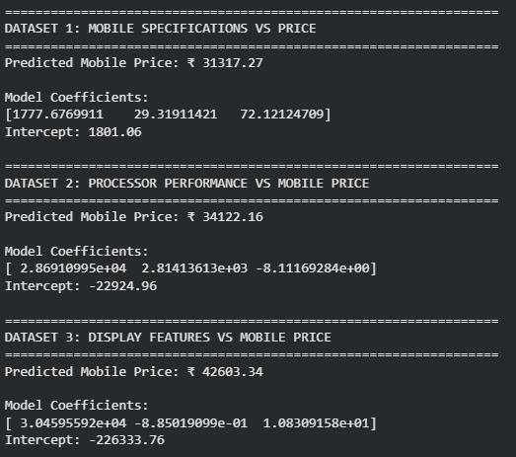
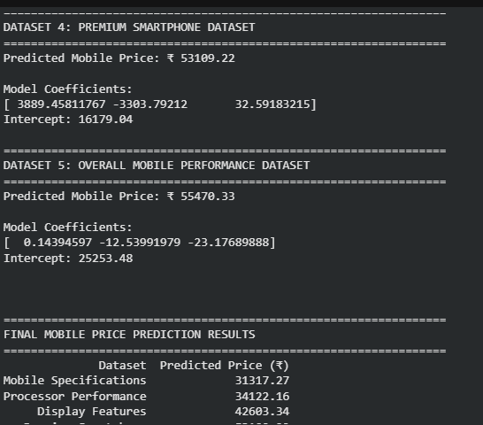

Result
Thus, the Linear Regression algorithm was successfully implemented to predict mobile phone prices from different smartphone specifications. The predicted prices for all five new samples were obtained successfully.

